SQL :

SQL is a database language which is introduced by ibm to communicate with database.

It is not case sensitive. Which means you can give uppercase case / lower case / combination of both.

Industry recommended : write the SQL queries in the upper case.

SQL commands are mainly categorized into 5 types they are

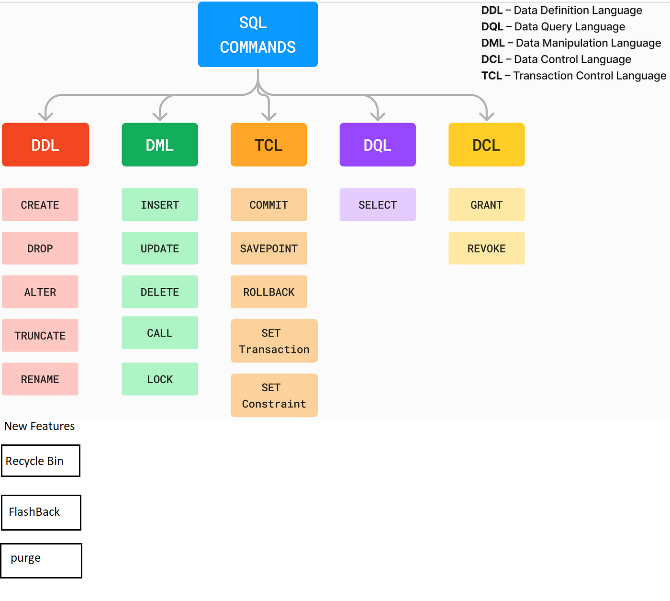

DDL

CREATE : this command is used to a new database object such as tables, views , synonymous , sequences, procedures , functions ,etc..